Assignment 3 – Deploy index.html from different repos to httpd
3 repos-

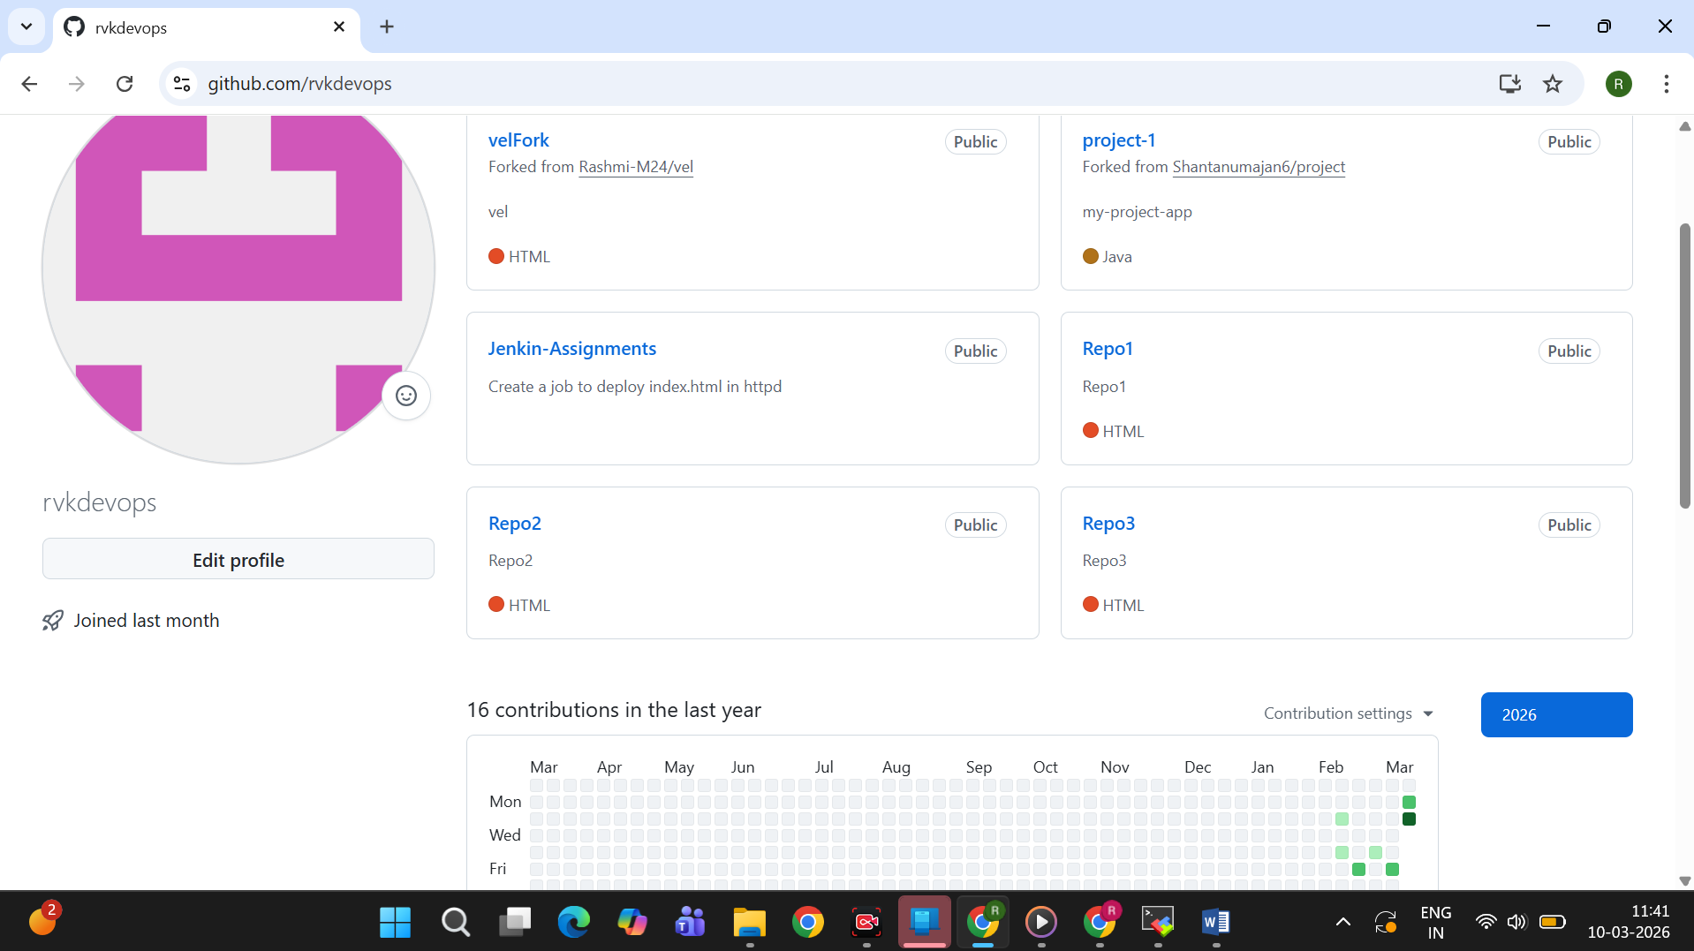

Job1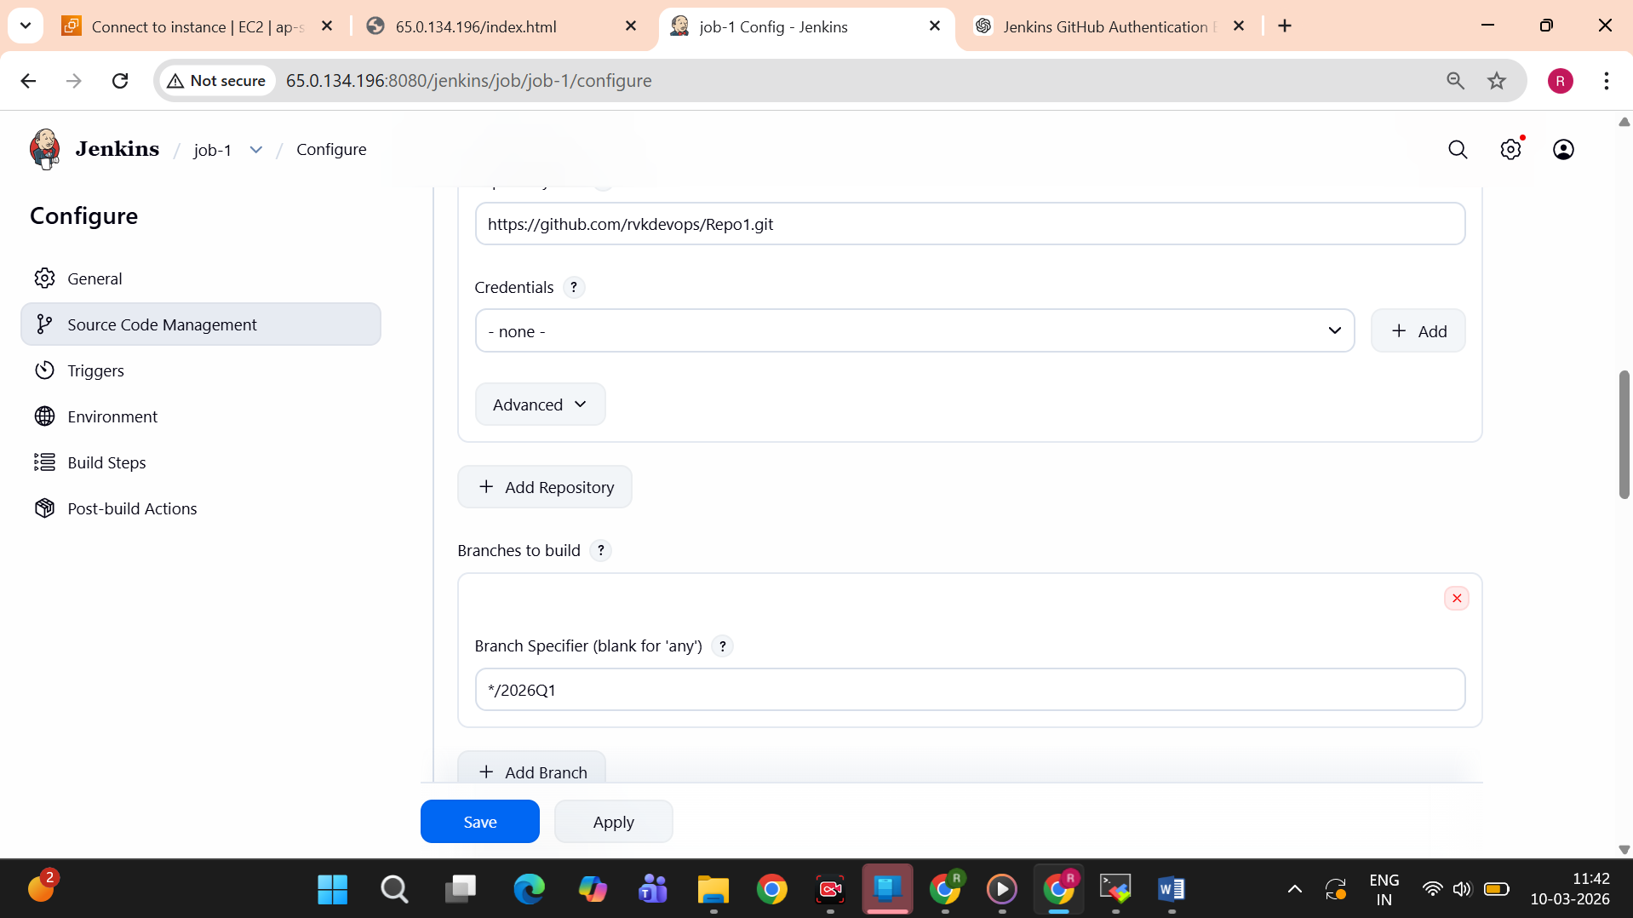
build steps-
sudo rm -rf /var/www/html/*
cp -r * /var/www/html/
sudo chown -R apache:apache /var/www/html
sudo chmod -R 755 /var/www/html
output-
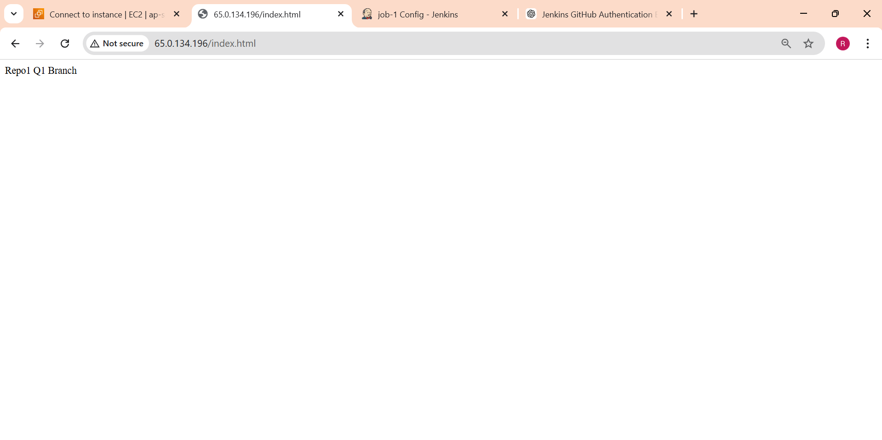
Job 2-
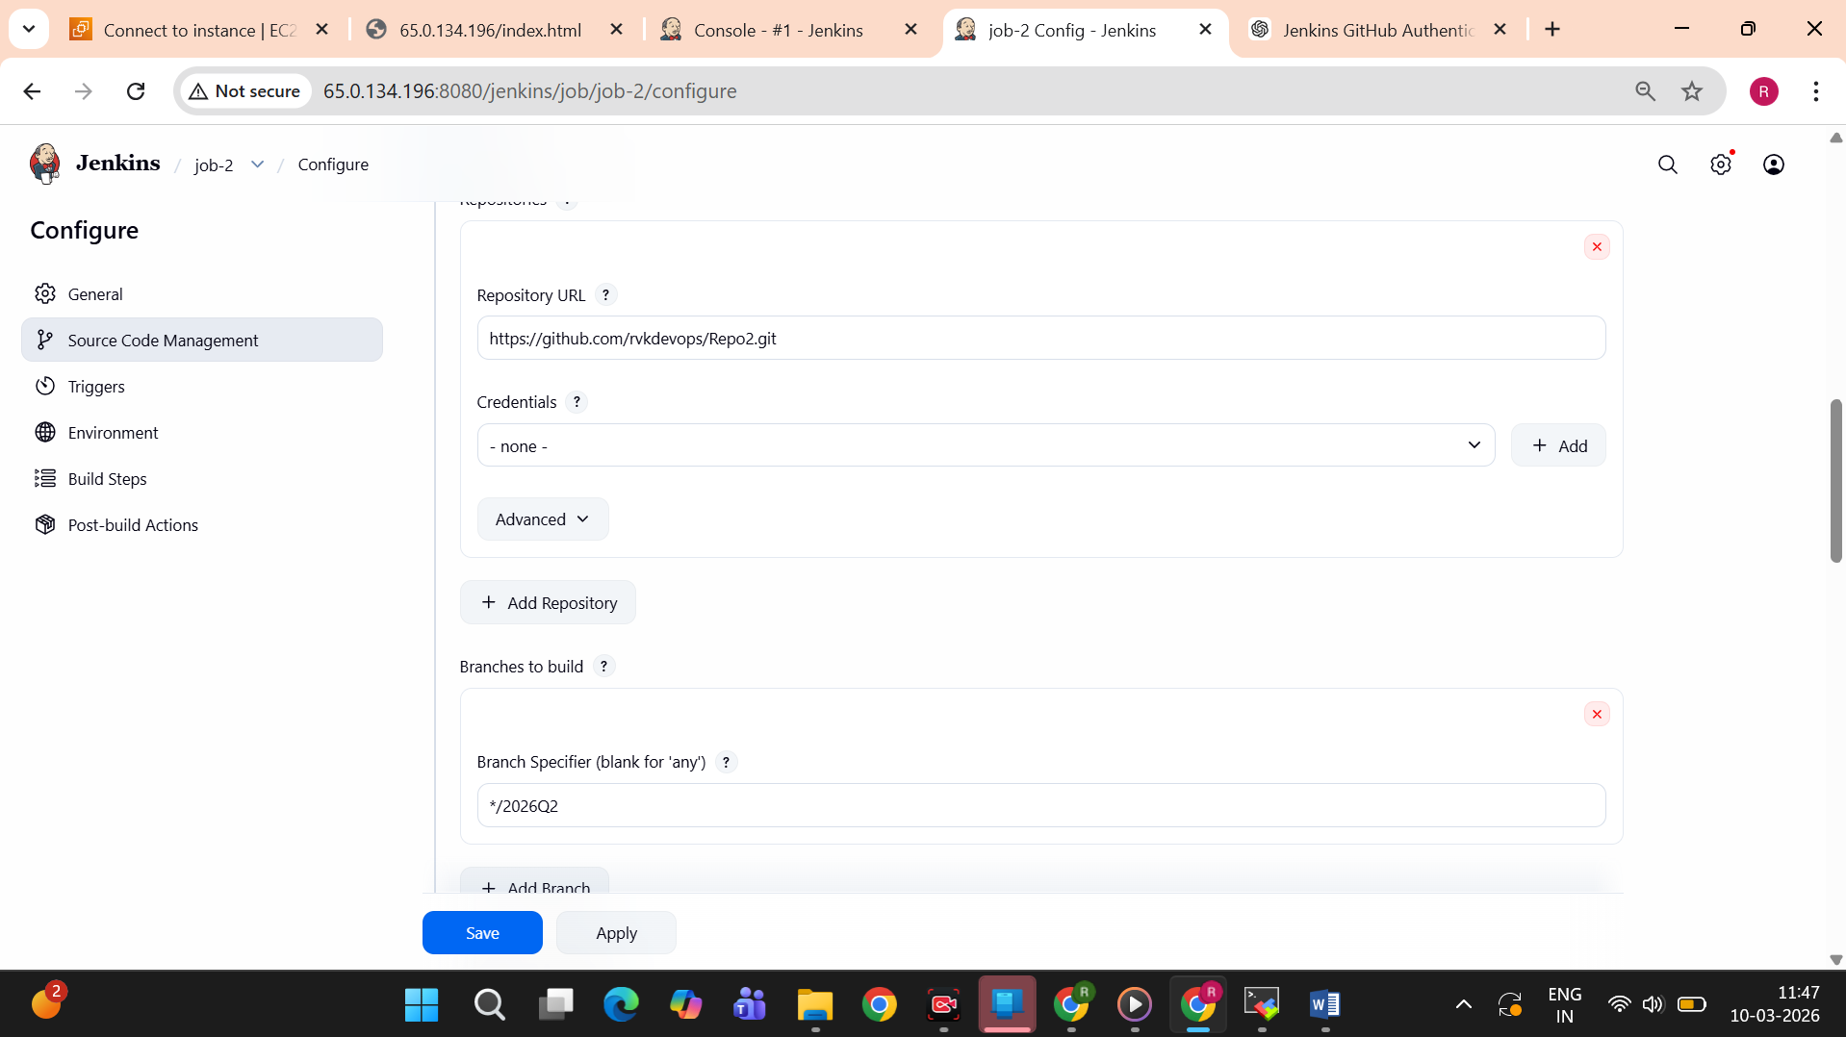
build steps-
sudo rm -rf /var/www/html/*
cp -r * /var/www/html/
sudo chown -R apache:apache /var/www/html
sudo chmod -R 755 /var/www/html
output-
